**3. Working with Data: Data Validation, Pivot Tables & Pivot Charts.**

**Data Validation:** Data validation in Excel helps ensure that users enter the correct type of data or values into a cell. It can be used to create rules that restrict the type of data, such as whole numbers, decimals, dates, times, and text lengths. It can also be used to create custom formulas

1. **Select the Cell/Range:**
   * Click on the cell or highlight the range where you want to apply data validation.
2. **Go to Data Tab:**
   * Navigate to the "Data" tab on the Excel ribbon.
3. **Data Validation:**
   * In the "Data Tools" group, click on "Data Validation."
4. **Criteria:**
   * In the "Data Validation" dialog box, choose the criteria tab (e.g., Whole Number, Decimal, Date, List, etc.).
   * Set the specific criteria and conditions.
5. **Input Message and Error Alert:**
   * Optionally, go to the "Input Message" tab to add a message that appears when the cell is selected.
   * Go to the "Error Alert" tab to set up an alert for invalid data.
6. **Finish:**
   * Click "OK" to apply the data validation.

**Pivot Table:** A PivotTable in Excel is a tool that summarizes large amounts of data in an interactive way. It allows you to analyze numerical data in detail and answer questions about your data

1. **Select Data:**
   * Highlight the range of cells containing your data.
2. **Insert Pivot Table:**
   * Go to the "Insert" tab on the ribbon.
   * Click on "Pivot Table."
3. **Choose Rows and Columns:**
   * In the "Create PivotTable" dialog box, ensure the range is correct.
   * Drag fields to the Rows and Columns areas to structure the table.
4. **Values:**
   * Drag fields to the "Values" area to perform calculations on those values.
5. **Filter and Sort:**
   * Use the filter options within the pivot table to customize the view.
6. **Format:**Format the pivot table as needed by adjusting cell formatting options.

**EXAMPLE FOR Pivot Table:**

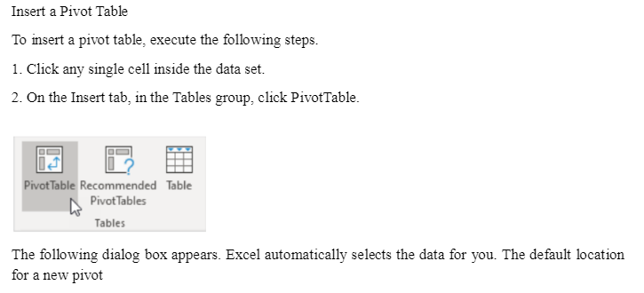



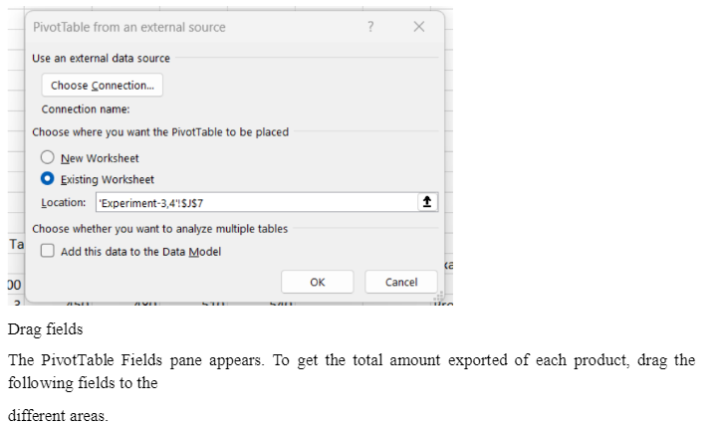



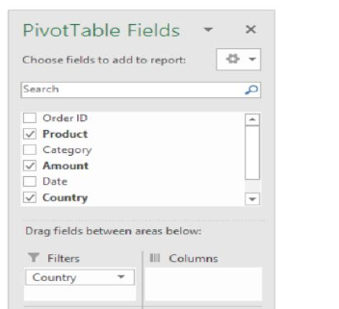

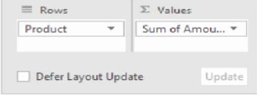

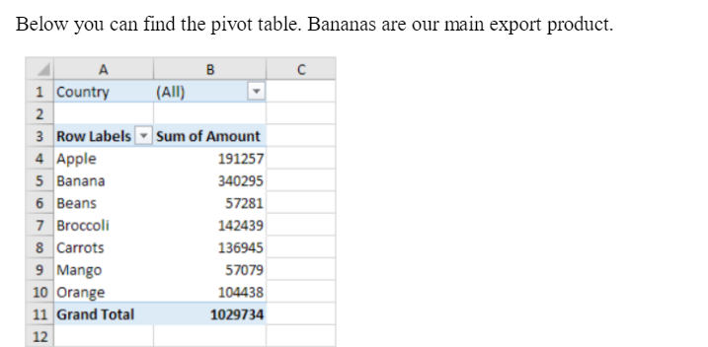

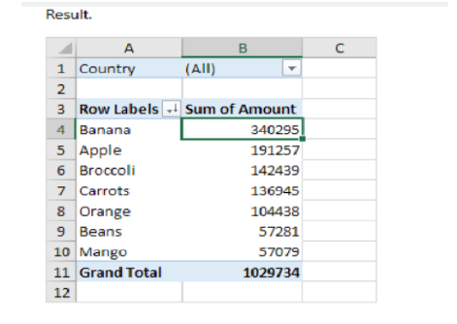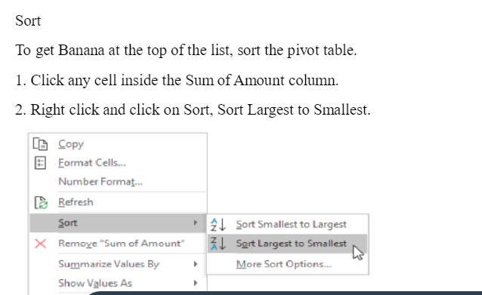

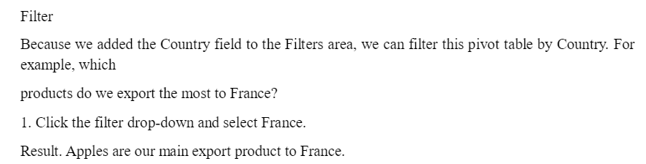

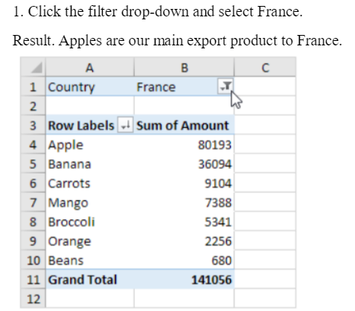

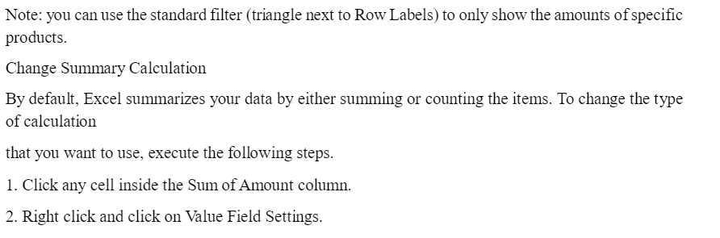

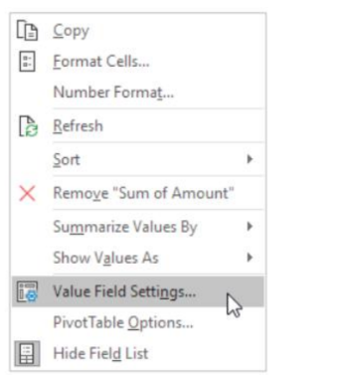



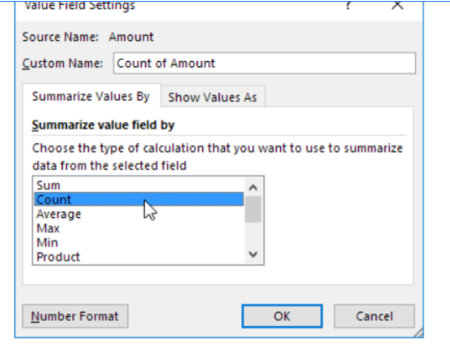

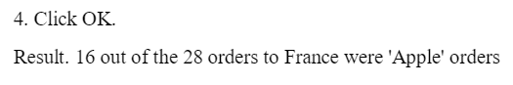

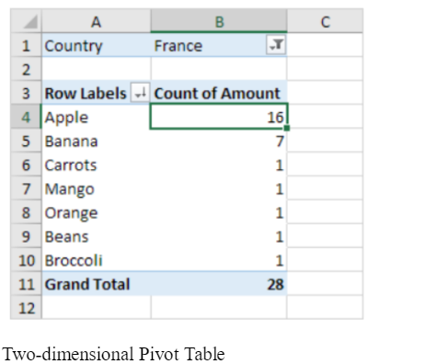

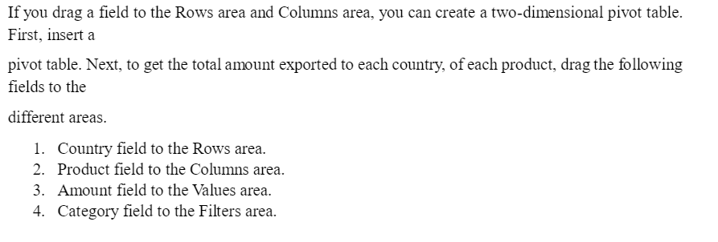

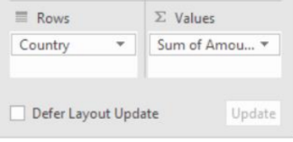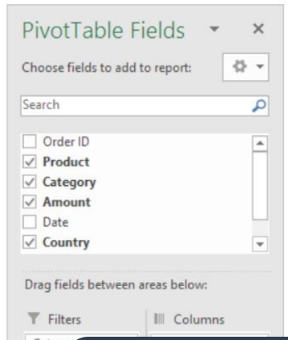

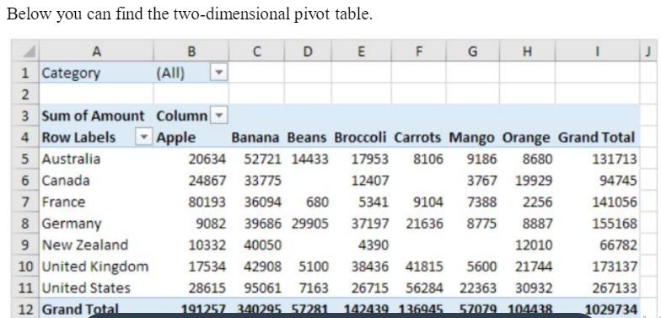



**Pivot Chart:**is a graphical representation of data in a PivotTable that's interactive and can be customized

1. **Create a Pivot Table:**
   * Before creating a pivot chart, you need to have a pivot table. Follow the steps above to create one.
2. **Select Pivot Table Data:**
   * Click anywhere in the pivot table.
3. **Insert Pivot Chart:**
   * Go to the "Insert" tab on the ribbon.
   * Click on "PivotChart."
4. **Choose Chart Type:**
   * In the "Insert Chart" dialog box, select the desired chart type (e.g., Column, Line, Pie, etc.).
5. **Configure Chart Fields:**
   * Drag fields to the chart areas (Axis, Legend, Values) to set up the chart.
6. **Format:**
   * Customize the chart title, axis labels, colors, and other formatting options as needed.

